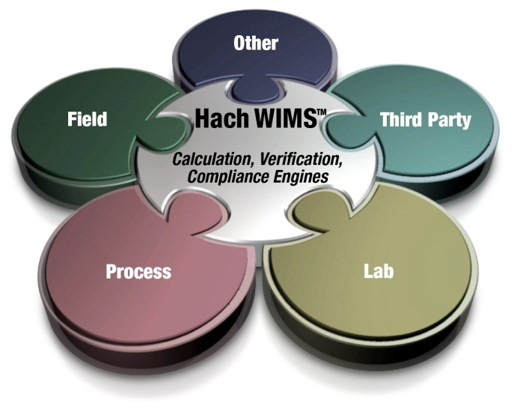

Administrator’s Guide

Hach WIMS Multi-User/Enterprise

With MS SQL Server Database Support

|  |  |  |
| --- | --- | --- |
| **Version** | **Date** | **Comments** |
| 1.0 | July 15, 2014 | WIMS 7.5 |
|  |  |  |

**Table of Contents**

1.1 Introduction 3

1.2 Hach WIMSTM System Requirements 4

1.3 System Overview 5

1.4 Installation Preparation 7

1.5 New Installation 8

1.6 Hach WIMS Server Setup 11

1.6.1 Create Hach WIMS Root Tables 11

1.6.2 Creating New Hach WIMS Facilities 12

1.7 Database Upgrades 14

1.8 Hach WIMS Services 16

1.8.1 INI Files 16

1.8.2 ADOCALC 17

1.8.3 DBAHelper 17

1.8.4 Email Gateway 17

1.8.5 GNR Server 18

1.8.6 Scheduler 18

1.8.7 Watchdog 18

1.9 GNR Server Service Setup 19

1.9.1 GNR Server Service as Administrator 19

1.9.2 GNR Server PDF Printer 19

1.10 Updating the Hach WIMS Client 23

1.11 Hach WIMS User Messages 24

1.12 Backing up a WIMS Facility 24

1.13 Restoring a Hach WIMS Backup 24

Appendix A: Enabling Relaying on your Email Server for Hach WIMS 25

# 1.1 Introduction

The Hach Water Information Management Solution™ with Database Support (referred to as Hach WIMS­­TM or WIMS in this manual) is a data management system specifically designed for water and wastewater facilities. It allows tracking, reporting, graphing, and analysis of facility data including SCADA, lab, and operator entered data. The Hach WIMS­­ system consists of a rich front-end client running on each user’s PC with a backend Microsoft SQL database. This manual is intended to assist the administrator install, configure, and maintain the WIMS­­ system.

This manual covers two editions of Hach WIMS: WIMS Multi-User with MS SQL Database Support and WIMS Enterprise with MS SQL Database support. The two editions are very similar with regard to administration and vary only in the number of users and facility databases that can be purchased.

**Hach WIMS Multi-User with MS SQL Database Support:**

Base features:

* Unlimited Variables and Facility Database Size
* Support for MS SQL Server 2005, 2008, 2012, or 2014
* Scheduled Output of reports and graphs (GNR Server)

Allows you to purchase:

* Up to 20 Concurrent Users
* Up to 20 Facility Databases
* Unlimited number of interfaces

**Hach WIMS Enterprise with MS SQL Database Support:**

Base features:

* Unlimited Variables and Facility Database Size
* Support for MS SQL Server 2005, 2008, 2012, or 2014
* Scheduled Output of reports and graphs (GNR Server)
* Load balancing calc engine

Allows you to purchase:

* Unlimited Concurrent Users
* Unlimited Facility Databases
* Unlimited number of interfaces

**Knowledge Base**

Our Knowledge base website has various articles and information to help the user. To access the knowledge base, visit <http://www.opssys.com/instantkb/>. Browse or use the search functions to find information for the various components of the Hach WIMS System. Throughout this guide are links to Knowledge Base articles for additional information and support.

# 1.2 Hach WIMS­­TM System Requirements

**Hach WIMSTM Client and Components**

**Operating system:**

* Microsoft Vista
* Microsoft Windows Server 2003 Service Pack 1
* Microsoft Windows Server 2003 R2 Service Pack 2
* Microsoft Windows Server 2008
* Microsoft Windows Server 2008 R2
* Microsoft Windows Server 2012
* Microsoft Windows Server 2012 R2
* Microsoft Windows 7
* Microsoft Windows 8, 8.1
* See <http://www.opssys.com/instantkb/Article.aspx?id=12215> for a complete list

**Data access:**

* Microsoft SQL 2005, MS SQL 2008, MS SQL 2012, or MS SQL 2014 (supplied by others)

**Hardware** (Minimum requirement for OK performance):

* 1 GHz processor (32 or 64-bit)
* 1 GB System RAM
* 10 GB of available disk space
* Screen resolution of 1024x768 with 32bit color depth
  + - * DVD-ROM

**NOTE:** Hach WIMS­­TM interfaces, Calc Engine, and GNR Server are designed to run as Windows services.

For Database server see the hardware requirements for your specific version and edition of MS SQL Server (<http://msdn.microsoft.com/en-us/library/ms143506.aspx#hwswr>)

**Hach WIMSTM DATABASE NETWORK BANDWITH SPECS**

Hach WIMS­­TM is based upon true client-server architecture. The client software has a large footprint and requires a speedy connection to the database server.

It is very hard to precisely state the minimum network bandwidth requirements for Hach WIMS­­. It was developed to work efficiently on a 10 Megabit network. Yet, depending on your current network bandwidth utilization, even 10 Megabit may not be enough.

We do not recommend deploying Hach WIMS­­ onto T1 bandwidth-rated networks. If you are bound by such network hardware, please consider running the Hach WIMS client on an application server (such as Windows Terminal Server or Citrix).

# 1.3 System Overview

The Hach WIMS­­TM data resides in a customer supplied MS SQL 2005 (or later) DBMS. The WIMS database stores data from a variety of sources including LIMS, SCADA, and manually entered. Raw data is calculated as needed and is stored in the database. WIMS is a full-featured program; there are some technical terms that are important to understand.



**Definitions:**

**Client/server:** An architecture in which the user's PC (the client) is the requesting machine and the server is the supplying machine, both of which are connected via a local area network (LAN) or wide area network (WAN). In this environment, servers are used to store and share data with the client PCs. The important concept of client/server is that both client and server each take on some of the application processing.

**Client software:** It is the Hach WIMS­­TM executable (Hach-WIMS_Client­­.exe) thatresides in a user's computer and is used to interact with the database. The client processes the user interface and can perform some or all of the application processing.

**Database Support:** Sometimes referred to as DB Support, allows Hach WIMS to utilize an enterprise Database Management System such as MS SQL Server (Enterprise, Standard, or Workgroup edition) or Oracle. Database Support is an add-on and is part of the software license.

**Concurrent Users:** Multiple users may log into the WIMS­­TM TM system at the same time. These users are concurrent users because they are accessing the system concurrently.

**Server software**: Software that resides in a server and provides services to multiple users on the network. A database server maintains the databases and processes requests from the client to extract data from or to update the database. An application server provides additional business processing for the clients.

**Named Users:** A unique name for each user that will use Hach WIMS Online. The online solution does not support concurrent users.

**Windows Services:** Applications that run in the background, that do not require login or have no user interface. Typically these are run on the server. Also known as NT Services.

**MSSQL DBMS:** The Microsoft SQL Database Management system (2005 or later) typically provided by the client.

**SMTP Server:** Server that is used to send email. (Simple Mail Transfer Protocol)

**Server\computer name:** The unique ID of a computer on a network. The computer name can be found in System Properties on the Computer Name tab.

**Variables:** Parameters, data tags or calculations to be tracked (influent flow, raw pH, etc.)

# 1.4 Installation Preparation

Hach WIMS­­TM Multi-User runs on a multiuser network. System Architecture Description:

1. Database Management Software (MS SQL) resides on one machine.

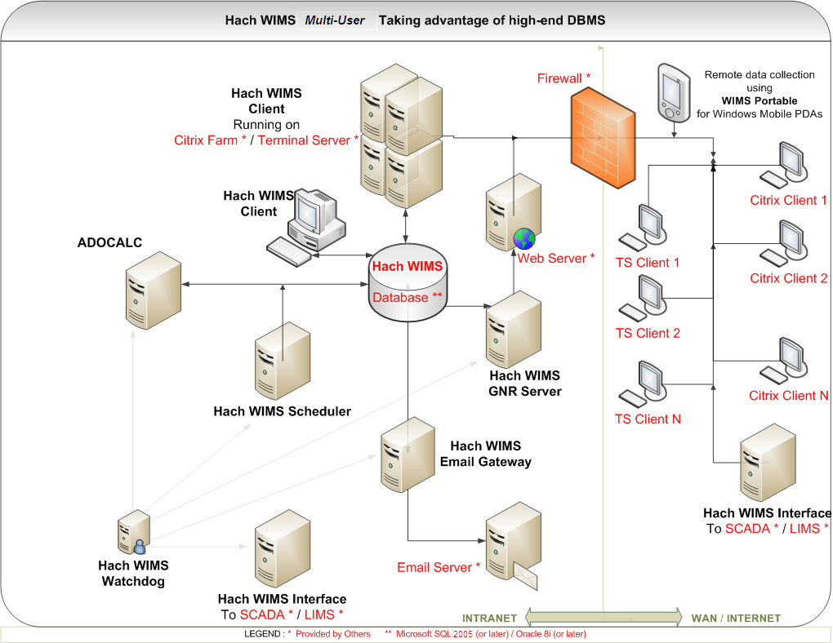

1. Client software is installed on any number of machines. Including terminal service machines.
2. Server software (ADOCALC, GNR Server, etc.) can split onto multiple computers, installed on an App server, or on the DB Server itself.

Additional definitions of the items and options for Hach WIMS­­:

**Server Setup:** Utility used to create WIMS­­ tables, stored procedures, upload clients, restore database backups, etc.

**ADO CALC:** The WIMS­­ Calc engine is a Windows Service that monitors the WIMS­­TM databases and calculates data as required so it is available for reports, graphs, etc. ADO Calc should be placed on a powerful PC that is close to the Server. **NOTE**: ADO Calc can run on the server, which will reduce network traffic and improve system performance.

**DBA Helper**: A WIMS Windows Service that performs backups of WIMS SQL Express databases. DBA Helper does not work with customer supplied DBMS.

**Live Update:** A WIMS Windows Service that checks the Hach WIMS­­ website for updates of available for install by the user.

**Email Gateway:** A WIMS Windows Service that connects to your SMTP mail server and relays the emails generated by the Hach WIMS­­ Client (i.e. you choose to output a report or graph to email) or emails generated by the GNR Server (e.g. reports or graphs that are output on a scheduled basis)

**Scheduler:** A WIMS Windows Service used to schedule output of report or graphs, database calculations, or database backups.

**GNR Server:** A WIMS Windows Service that receives requests from the scheduler to output reports and graphs, generates the output, sends the output to a printer, a file, or to email (i.e. it sends it to the email gateway)

**IABroker:** Facilitates the interaction of 3rd party software’s interaction with the WIMS System. (E.g. IFix)

**Watchdog** The Hach WIMS's Watchdog service is a background Windows Service that keeps watch on the connection to the database and will restart the other services in the event of a connection lost.

# 1.5 New Installation

Hach WIMS installation uses the WIMS Platform Installer to assist while installing the WIMS Software. The process is the same whether installing one component or all the components.

**NOTE: If you are upgrading from a previous version (OPS SQL), please refer to Upgrading from 6.x.x in the Knowledge base.**

1. Close all programs that are currently running.

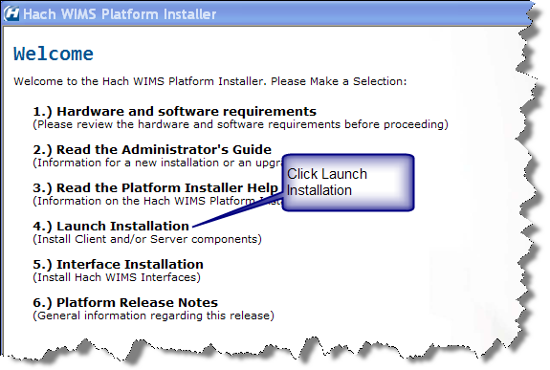

1. Insert the Hach WIMS DVD and the Hach WIMS Platform Installer Welcome will be displayed. If the Welcome screen does not appear, double click on d:\Launcher\Launcher.hta where d: is your DVD drive.
2. Click **Launch Installation** option from the Hach WIMS­­ Platform Installer Welcome.

**NOTE: You may see a Prerequisites Wizard if any of the prerequisites are not installed. Please install using the Prerequisites Wizard to continue installations (.Net Framework 2.0 SP1 is a common missing prerequisite).**

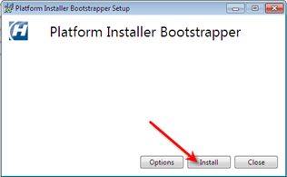

4. Platform Installer Bootstrapper will be displayed. Click .



Note: Depending on your OS, you may be prompted to allow the program to make changes to your computer (User Access Control). Click **Yes** if prompted.

1. The Platform Installer will ask you to review and agree to the License Agreement. Check the Box if you agree and click **Next**.

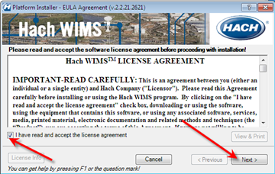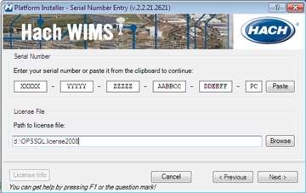

1. The Platform Installer will launch. Enter your Serial number and Browse to your License File (a file with a .License2008 extension, should be located in the root folder of your WIMS DVD). Click the **Next** button. Your Serial Number should be on the WIMS DVD Case or it may be emailed to you.
2. The Platform Installer will search for Hach WIMS­­ MSI locations. You may need to browse to the MSI Location using the Browse button. When a location is found, a popup will inform you. Click **Next**. If you are installing from the DVD, click **Next**.

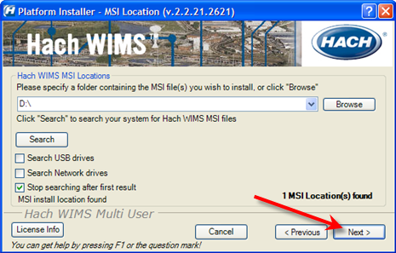

1. When you have selected the components you wish to install, click the **Next** button.

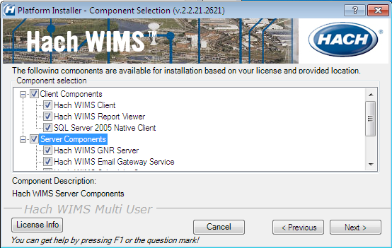

* 1. Server – The Server components may be split between multiple machines. Each machine must have a connection to the machine hosting your database. Select the Components for this machine.
  2. Client - If you are installing just the client select only the client components and **none** of the server components.

1. Choose your default installation directory and your MS SQL Server Instance that will host your WIMS databases. The directory you choose will be the default and each component will be installed with this directory in mind.  
     
     
     
     
     
     
     
     
     
   **NOTE:** The MS SQL Server Instance is usually the host computer name\instance name. The host name only can be used if you are using the default MS SQL instance on that PC. This field should be set to the same as the Server name setting when using Microsoft SQL Server Management Studio Connect to Server form. See your DBA for your Server\Instance Name.

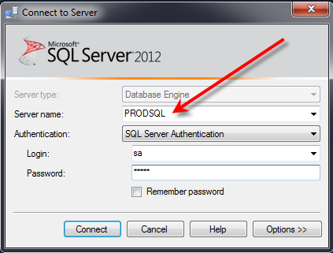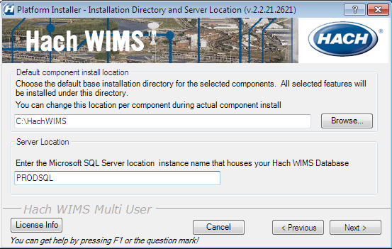

1. The Platform Installer will list the Components that you selected and prepare them to be installed. Click the **Begin** button. Each Component will have its own installation wizard. Complete each wizard. See the Component Installation section for help with each wizard. Once finished, press the finished button. Hach WIMS is now installed.

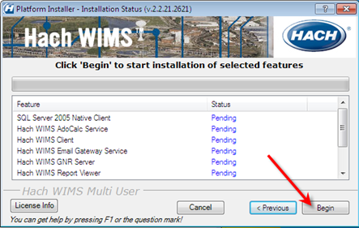

**NOTE:** Depending on your operating system and settings you may need to grant privileges to users so they can use WIMS. WIMS needs users to be able to create/write/modify files in the HACHWIMS folders and subfolders. This most commonly needs to be done in Windows 2008 R2 and Windows 7:

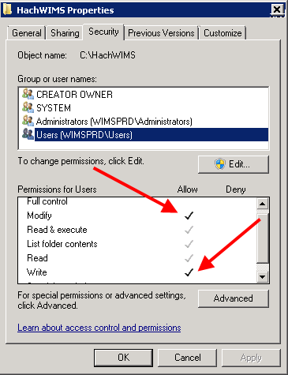

1.6 Hach WIMS Server Setup

The Hach WIMS Server Setup program allows the administrator to create new databases, restore backed up databases, import OPS 32 databases, and perform database upgrades.

## 1.6.1 Create Hach WIMS Root Tables

The utility needs access to an existing **MS SQL Server**. The first time Server Setup connects to the DBMS, it will prompt for the SQL Server SA username and password and create the WIMS base structures. **Note:** This login information is not stored by any Hach WIMS product once the structures have been created.

1. Run Hach WIMS Server Setup (MSSQL Edition).

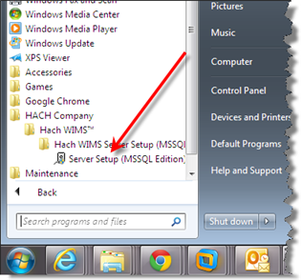

1. Click **Next** at the Welcome Screen:

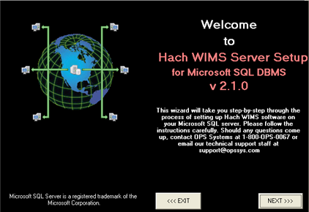

1. Connect to the Database:

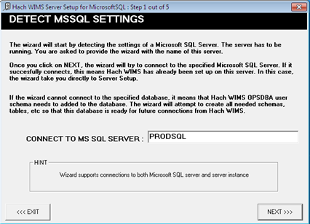

1. If this is the first time you are connecting Server Setup to this DBMS, you will be prompted for the SA username and password. Enter your SA Username and password and click **Next**:

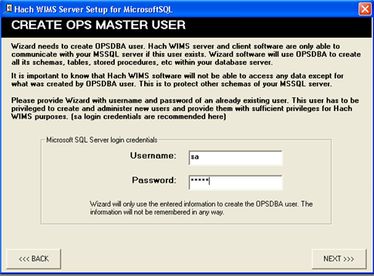

Server Setup will create the OPSDBA user and the OPSROOT database in the MS SQL Server DBMS. Server Setup will exit and you are now ready to create WIMS Facility Databases.

## 1.6.2 Creating New Hach WIMS Facilities

This process will require you to specify a unique identifier and a facility name for the new facility. The unique identifier is used to create a database under which all tables, stored procedures, and triggers will be held for the new facility.

**Unique Identifier:** This field can only contain letters. No numbers or other special characters. You are limited to a maximum of 8 characters

**Data Source:** The MS SQL Server that will be hosting this database.

**Facility Name:** You should use your common facility name. If you call your plant Rocky Creek WWTP – type in Rocky Creek WWTP.

Use the server setup utility to create a new Hach WIMS­­ database. Specify a unique identifier, data source, and a facility name for the new facility.



1. Run **Hach WIMS­­ Server Setup**.

1. Click **Next**.

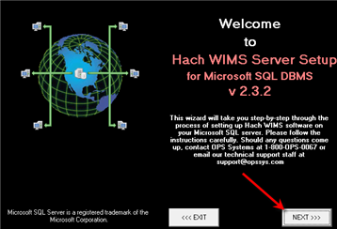

1. Your MSSQL Server Name should already be in place. If it is not, enter it here. (Computer Name/Instance – e.g. PRODSQL). Click **Next**.

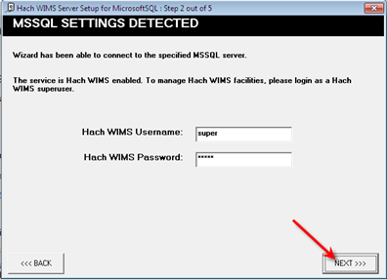

1. Enter a Hach WIMS­­ Username and Password and click **Next**. The system defaults to:

Username: Super

Password: Super

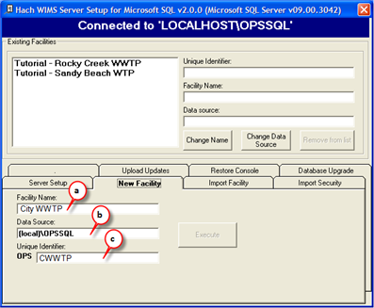

1. Click on the **New Facility Tab** to name your database. You must enter information into the following fields:  
      
   **a. Facility Name:** You should use your common facility name. If you call your plant City WWTP – type in City WWTP.

**b. Data Source:** This should match the server you are connecting to.

**c. Unique Identifier:** A short identifier for the new database. This field can only contain letters. No numbers or other special characters. You are limited to a maximum of 8 characters.

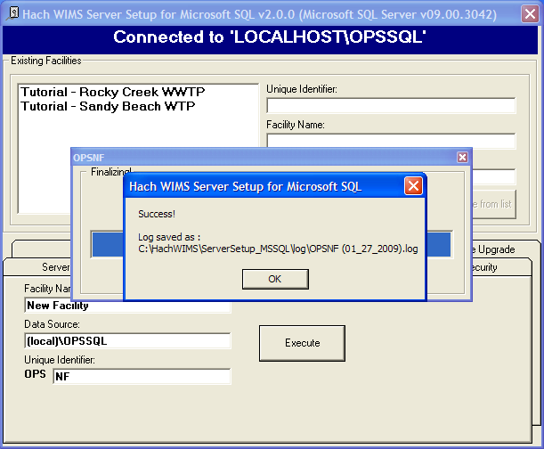

6. Click **Execute**. The Server Setup will create a new database and display the Success message:

7. All new facilities are upgraded to the latest database version during their creation. This means you should be able to login to your new facility immediately.

# 1.7 Database Upgrades

The facilities in the Hach WIMS system may not be up to date with the current version of Hach WIMS. Upgrade these facilities using Server Setup in order to use them.

NOTE: All users must exit WIMS­­ before proceeding.

1. Start **Server Setup**.



1. Click **Next** to Start Server Setup:

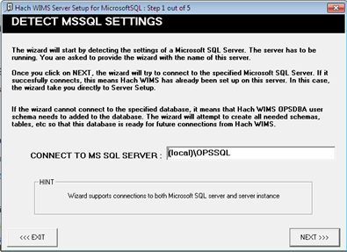

1. Input Server/Instance Name. Click **Next**.



1. Input Username and Password and click **Next**. The default Username and Password are:

Username: Super

Password: Super

1. Select the **Database Upgrade** Tab.
2. Click the **Refresh** button to get a list of databases that are not up to date.
3. Press the **Database Upgrade** Button. This will upgrade all the databases in the list.

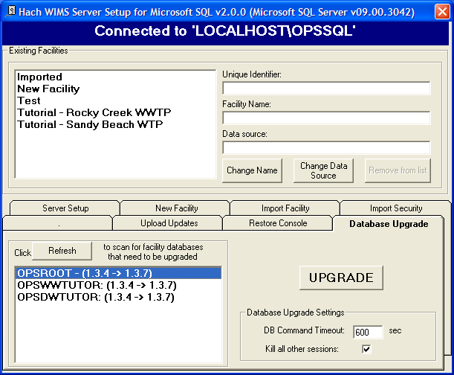

1. The system requires full access to the database. It will terminate the connection for anyone currently logged in. Once the update is complete, restart your ADOCALC and GNR services. If you understand these requirements, click the **Yes** button.

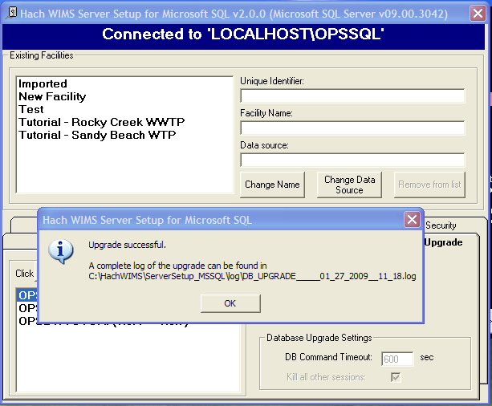

1. Upon Success you will be able to log into any of the upgraded facilities.

# 1.8 Hach WIMS Services

Hach WIMS installs several Windows services. These services perform a variety of tasks that are essential for Hach WIMS to run properly. To view your services and to verify they are running, start “**Services.msc**”.

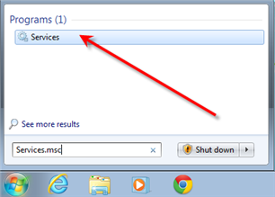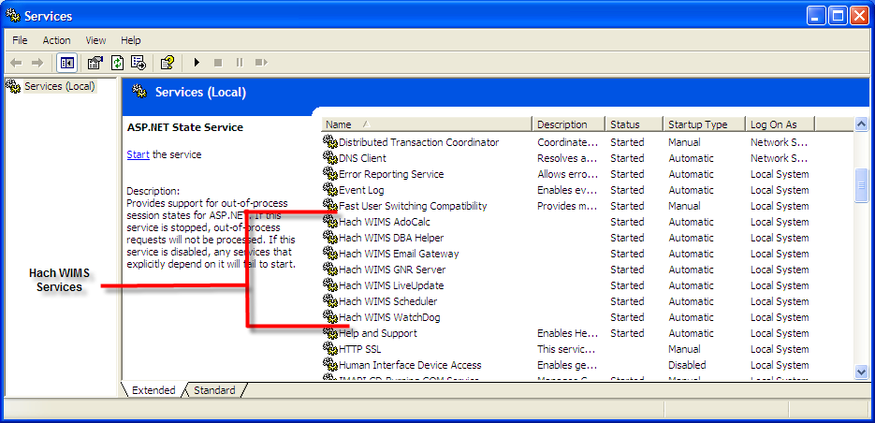

Hach WIMS Services and the MSSQL service should have a Startup Type of Automatic and the Status should always be started. If you are having problems with a service, you may want to restart it from the start menu. Go to each services folder and find the restart services item.

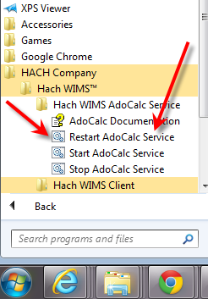

## 1.8.1 INI Files

Services in Hach WIMS use INI files to set up some basic initialization settings. All INI files share at least 3 fields. Additional Fields will be listed under each service’s section. INI Files are located under each service’s directory in the Hach WIMS root directory. (Default is C:\Hach-WIMS­­) INI Settings are formatted as ATTRIBUTE=VALUE. Following are attributes and acceptable values.

***HACHWIMS_CONNECTION_DBTYPE:***

For Hach WIMS (with DB Support), this can be equal to 1 or 2. 1 means MS SQL and 2 means Oracle.

***HachWIMS_Connection_Provider:***

This signifies the OLEDB provider that ADOCALC should use. SQLNCLI for SQL Server 2005, SQLNCLI10 for SQL Server 2008, SQLNCLI11 for SQL Server 2012/2014.

***HachWIMS_Connection_Datasource:***

This is your Server Name\Instance Name of the Hach WIMS database that this service will interact with.

## 1.8.2 ADOCALC

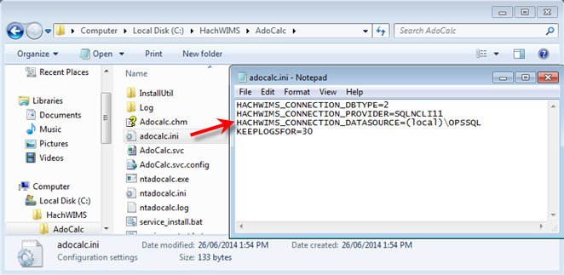

ADOCALC is the Hach WIMS calculation engine. It should be online and connected to your database at all times. When a Hach WIMS Client calculates data, it sends a calculation request to ADOCALC, the ADOCALC service then performs the calculation and notifies the client that the calc is complete. Example ADOCALC.INI:

***KEEPLOGSFOR***

The ADOCALC service creates extensive logs of its activity. These logs are located in the log subfolder (default c:\HachWIMS\adocalc\log). This sets the number of days that the log files are kept.

## 1.8.3 DBAHelper

DBAHelper only works with MS SQL Express databases installed by the WIMS installer and therefore is NOT supported with WIMS-Multiuser/Enterprise with MS SQL DB support.

The client is responsible to back up the WIMS database.

## 1.8.4 Email Gateway

Sends emails that are created by Hach WIMS to a specified SMTP to be delivered via email. For additional Information please consult our Knowledge Base. <http://www.opssys.com/instantkb/Article.aspx?id=12003>

The INI File has 6 additional fields.

***KEEPLOGSFOR***

Number of days logs will be saved.

***SMTP***

Specifies the SMTP Server.

***SMTPPORT***

Specifies the port that the SMTP is expecting data to be pushed through.

***SMTPAUTH***

This tells the email gate way if the SMTP will require authentication (login and password). A value of 1 states authentication is required. Anything else means authentication is not required.

***SMTPUSER***

The Username of this SMTP Server’s authentication. This will only be completed if SMTPAUTH is set to 1.

***SMTPPASSWORD***

The Password for this SMTP Server’s authentication. This will only be completed if SMTPAUTH is set to 1.

## 1.8.5 GNR Server

The Hach WIMS GNR Server service sends scheduled reports and graphs to their scheduled output (email, disk, or a printer). The GNR Service may require additional setup (see below in GNR SETUP section).

The INI File has 2 additional fields.

***KEEPLOGSFOR***

This is the number of days logs will be saved.

***HACHWIMSCLIENT***

This specifies the path to the Hach WIMS client.

## 1.8.6 Scheduler

The Hach WIMS Scheduler service keeps track of scheduled database backups, database calculations, scheduled reports, and scheduled graphs in the Hach WIMS System.

The INI File has 1 additional field.

***KEEPLOGSFOR***

The number of days logs will be saved.

## 1.8.7 Watchdog

The Hach WIMS Watchdog service assures all the other services are up and running. When one of its specified services stops illegally, the watchdog service will restart it automatically.

The INI File has 5 additional fields.

***KEEPLOGSFOR***

The number of days logs will be saved.

***POLL_EVERY_MS***

How often watchdog checks in on each service.

***CONNECTION_TIMEOUT_S***

How long watchdog waits for a service before it’s considered timed out.

***STAY_CONNECTED***

***NTSERVICE***

An NT Service that watchdog needs to keep track of. This entry can be added multiple times to add any NT Service.

# 1.9 GNR Server Service Setup

GNR may require additional setup depending on how your system is configured. Log in as an administrator on the computer GNR is installed on. Set up the printer for the GNR administrator user that GNR will have access to (including a PDF Printer).

## 1.9.1 GNR Server Service as Administrator

Services run under the Local System Account do not have access to printer information. In order for the GNR Server to interact with your printers, the GNR Service **MUST** be run under an admin account.

1. Open up **Services.msc** (go to start->run)

2. The services.msc window will open up. Search for the Hach WIMS GNR Server Service.

3. Right click the Service and select properties.

4. Select the **Log On** Tab.

5. Select the “**This Account**” Radio button.

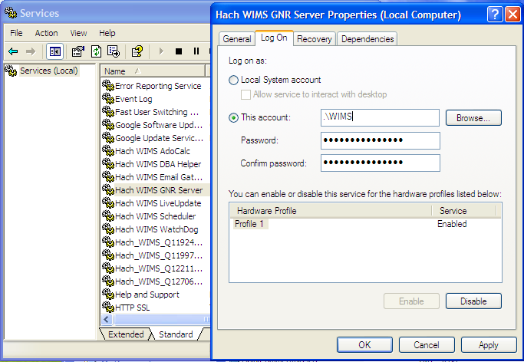

6. Type in a Windows administrator’s account Username and Password

7. Click **OK**. This should change the login information for this service.

## 1.9.2 GNR Server PDF Printer

When you set up GNR to run under an administrator account, GNR has access to printers only added to that account. If you would like to have PDF capabilities, you will need to add a PDF Printer to the User account that GNR Server was setup to run under. Please Visit <http://www.opssys.com/instantkb/Article.aspx?id=10032> for further instructions and access to files.

1. Login as the Windows User that GNR Server is running under (WIMS in example above)
2. Go to **Start/Settings/Printers And Faxes**
3. Install at least one printer driver. This driver can be a "dummy driver" and does not need printer hardware behind it. To have GNR server print to multiple print locations, set up all drivers needed.

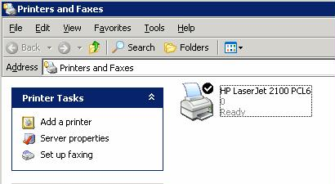

1. Run **pdf995_v12.exe** (Downloaded from Knowledge base article, <http://www.opssys.com/instantkb/article.aspx?id=12741> ). Choose a path where you want to extract the installation files.

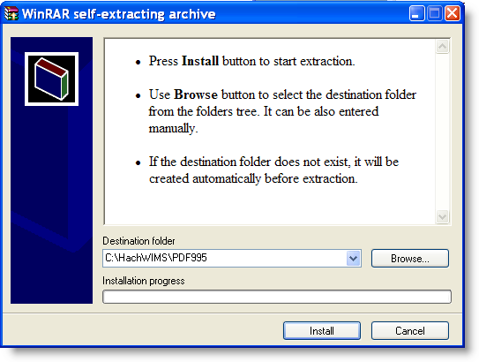

1. Click **Install**. The files will be extracted and the program will close.

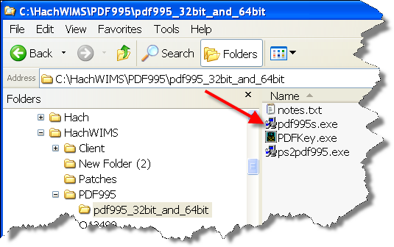

1. In explorer, navigate to the directory where you just extracted the installation files.

1. Run **pdf995.exe**. Let it run through the installation process.
2. Once it’s done, Answer **NO** to the following message:

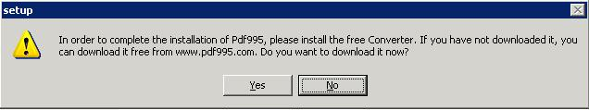

1. Run **ps2pdf995.exe,** answer **Accept** to the Pdf995 User Configuration message that will appear at the end of the install.
2. The installation will confirm success with a browser message:

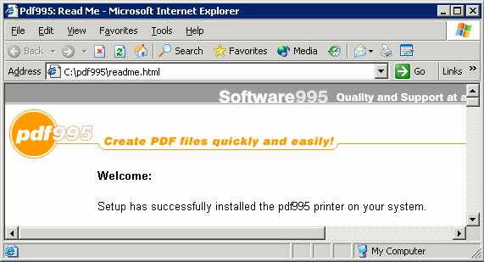

1. Run PDFKey.exe
2. Type in your name and the PDF995 key value (pedro3).

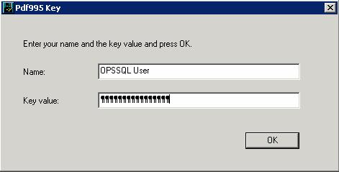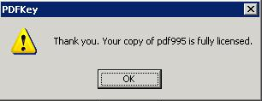

1. Click **OK** and you should see the following message:

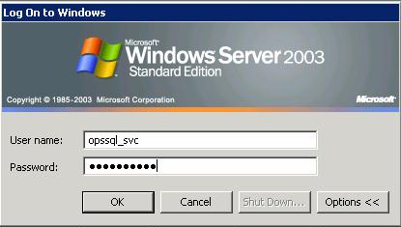

1. Log into the PC as the GNR User. Go to **Start/Settings/Printers and Faxes**

1. You should see PDF995 in the printers list

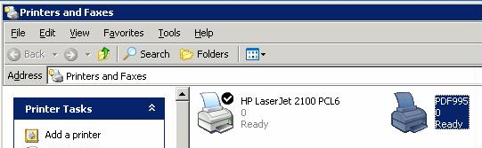

1. Right-Click on **PDF995 and select Rename**

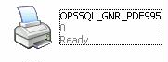

1. Rename to OPSSQL_GNR_PDF995
2. **Right click on OPSSQL_GNR_PDF995** and select **Properties**:

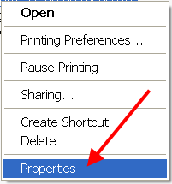

1. Set the OPSSQL_GNR_PDF995 Printer property on the advanced tab to "Start Printing immediately":   
     
     
   **NOTE:** This step addresses several issues users have had when emailing PDFs though GNR Server. You may also need to use **PDFSLEEPEXTRAMS** [Hach_WIMS_Client.ini](http://www.opssys.com/instantkb/Article.aspx?id=10447) setting (typically not required).

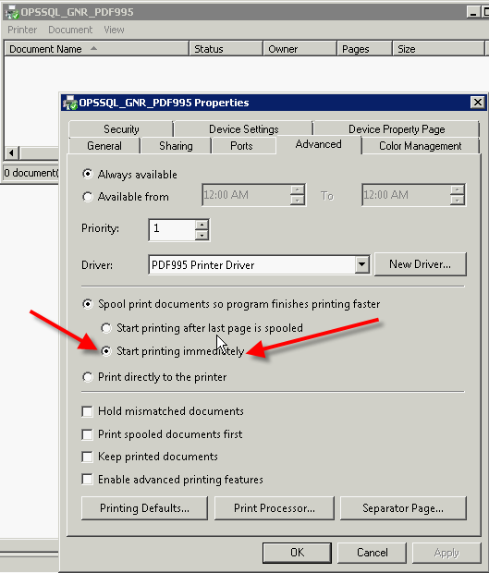

1. In Explorer, navigate to the Hach WIMS­­ Client folder
2. Open Hach_WIMS_Client.INI and add the following 3 settings at the end of the file:

PDFINIPATH=C:\pdf995\res

PDFINIFILE=pdf995.ini

PDFSYNCFILE=pdfsync.ini

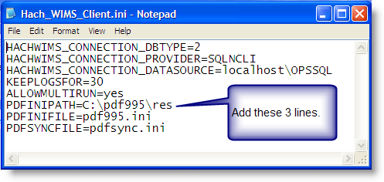

1. Save Hach_WIMS_Client.INI
2. Start the GNR Server Service.

# 1.10 Updating the Hach WIMS Client

Updates are periodically released to fix bugs and add minor features to the Hach WIMS­­ system. The Hach WIMS support portal contains the update software to download.

Extract the update. Push the update into the server. Tell the server to disallow any user below a certain version. As users login, they will be forced to update.

1. Visit [www.hachiim.com/support](http://www.hachiim.com/support)
2. If you do not have an account, create one. Log in.
3. If you created your account, add your product License number.
4. Enter the Hach WIMS­­ Support area.
5. Download the latest version of the Hach WIMS­­ Client.
6. The Client update is an EXE that when run will extract a Setup Program. Run this EXE and extract the files.
7. Run **Server Setup. Start->All Programs->Hach Company->Hach WIMS­­->Hach WIMS Server Setup (MSSQL)** and **login**.

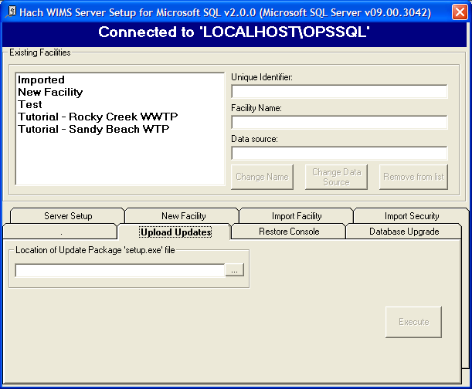

1. Go to the **Upload Updates** Tab.

1. Browse to the location where you extracted the update. Select **Setup.exe**
2. Once you select the setup EXE you will be presented with basic information, such as the version number for the update. You will need this number for later.
3. Once the Update has loaded, close Server Setup and Open the Hach WIMS­­ Client.

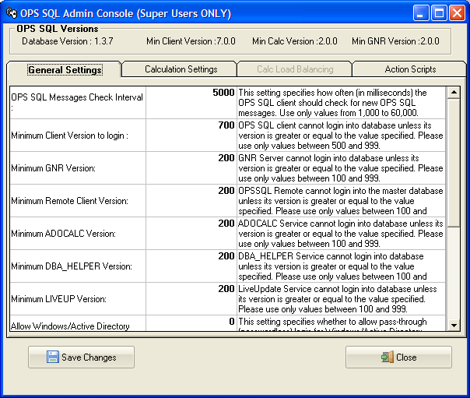

1. The update is stored in the database as a blob file that can be retrieved by any client. To force the clients to update, **Open System Setup->Admin Console**.

1. Change the setting called “Minimum Client Version to Login:” to the version number that was just downloaded without any periods (7.0.0 is typed in as 700). When a client tries to connect to the server that does not meet this requirement, they will be asked to confirm an update to their client.

# 1.11 Hach WIMS User Messages

Hach WIMS comes with a messaging system that allows any Hach WIMS user to send a message to any other Hach WIMS user.

The Hach WIMS Services (ADOCALC, DBA_Helper, interfaces, etc.) will use these user messages to report about their behaviors. You can also apply a user message to ‘ping’ the Services.

To Send a Message to a user or service, go to *Utilities*, *Send Message*:

To open your Inbox go to Utilities-> Message Inbox.

# 1.12 Backing up a WIMS Facility

In Hach WIMS (with DB Support), you must backup your database using your own Database Management software.

# 1.13 Restoring a Hach WIMS Backup

In Hach WIMS (with DB Support), you must restore your databases using your own Database Management software.

# Appendix A: Enabling Relaying on your Email Server for Hach WIMS

The GNR service allows Hach WIMS to send periodic emails, however Hach WIMS itself is not an email server. You must have a machine with an SMTP (email) server already setup. The PC on which the GNR service resides must be able to connect and use your SMTP server to actually send the email. This is called “relaying”. By default, relaying is usually disabled as a security consideration. You will need to enable relaying for the PC that is hosting the GNR service.

This guide will explain how to do this through Microsoft Exchange 2003, a popular email server.

**NOTE:** If you don’t feel comfortable with modifying Exchange settings, which can have far-reaching effects, please have your system administrator help you!

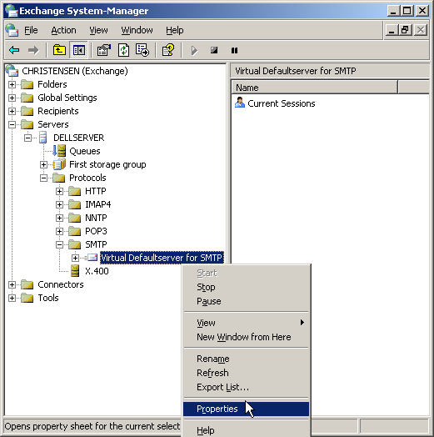

1. Open the Exchange System Manager console and navigate through the tree to Servers/Protocols/SMTP/Default SMTP Virtual Server:

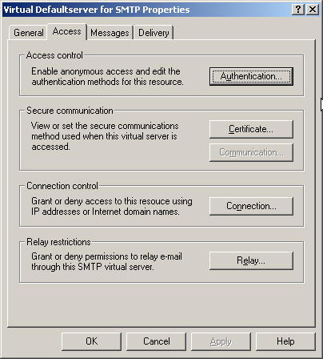

1. Click Properties and then click the Access tab:

Modify the Access Control, Connection and Relay Restriction options for email to go through. Note: that modification might be unnecessary if your Exchange server has already been setup properly.

1. Click the Authentication tab and enable the Anonymous Access option, the GNR service does not authenticate as a specific user:

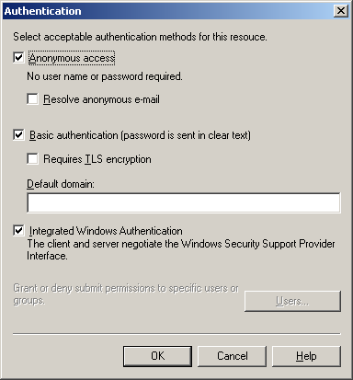

1. Mark the checkbox for Anonymous access and click **OK**. This will get back to the Access tab.

1. Click on **Connection**. Assure that the machine’s IP address that is hosting the GNR service is either listed as an allowed IP address, or is NOT listed as a blacklisted IP address.

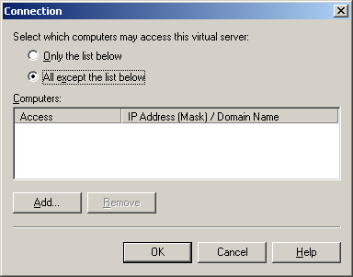

The two radio buttons, “Only the list below” and “All except the list below” control whether the listed IP addresses/Hostnames are either white-listed or black-listed. E.g., if the radio button “Only the list below” is selected and the GNR machine is NOT listed, email sending will not work because the machine is not in the white list; if it’s present in the list, all is OK. Conversely, if the radio button “All except the list below” is checked and the GNR machine IP address/hostname is NOT listed, email will work, if it’s in the list, it is black-listed and will get rejected.

The IP address should be present in the list if the first radio button is selected, or it’s NOT present if the second radio button is selected. Click OK to go back to the Access tab.

1. Click the Relay button to go to the Relay screen. This screen is similar to the Connection screen:

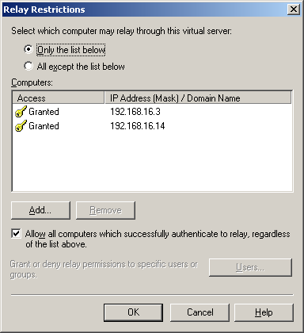

The logic is the same as in under the allowed connections screen, i.e., the “Only the list below” radio button controls the white-list and you MUST make sure the GNR machine is listed, while the “All except the list below” button controls the black-listed machines and you MUST make sure the machine is NOT listed. Click **OK**.

1. Disable your anti-virus program on the SMTP (email server) machine. This is necessary because the anti-virus program interferes with the way Hach WIMS sends emails.

**NOTE**: Modifying email settings can have serious security consequences. Please have your system or network administrator help you or do the actual modifications if necessary!